Nirma University
School of Engineering, Institute of Technology
Department of Electrical Engineering
2EE401: Control System Engineering
Assignment-1
Date of Issue: | Date of Submission:

Q.1 | Find the poles of following $F(s)$  $$F\left(s\right)=\frac{1}{1-e^{-s}}$$
Q.2 | Find the inverse Laplace transform of the following $F(s)$  $$F\left(s\right)=\frac{5(s+2)}{s^{2}(s+1)(s+3)}$$
Q.3 | Determine the block diagrams of the network shown in the Fig.1  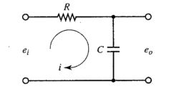  Fig.1
Q.4 | Determine the transfer function of the block diagram shown in Fig.2  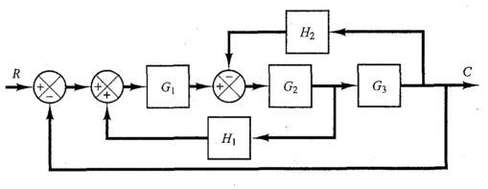  Fig.2
Q.5 | Simplify the block diagram of the mechanical system shown in Fig.3  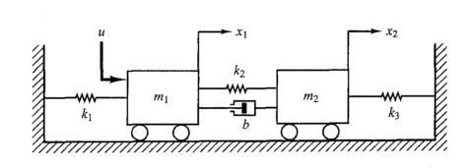  Fig.3
Q.6 | Construct the block diagram of the network shown in the Fig.4. Also show the capacitor currents using MATLAB simulation by considering${ R}_{1}=3Ω, R_{2}=1Ω, C_{1}=40μF, C_{2}=1000μF$ for input $u\left(t\right)=4δ(t)$. (Attach Plot)  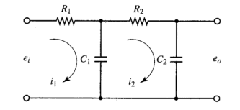  Fig.4
Q.7 | Obtain the transfer function of the block diagram shown in Fig.5 using Mason’s gain formula.  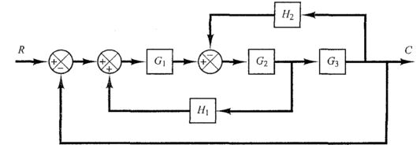  Fig.5
Q.8 | Obtain the closed loop transfer function of the network shown in Fig. 6, using block diagram reduction technique.  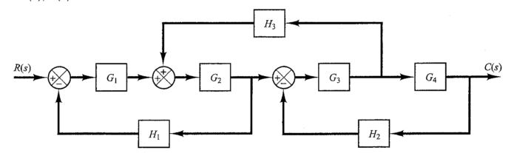  Fig.6
Q.9 | Obtain the voltage transfer function of the bridge transfer function shown in Fig.7.  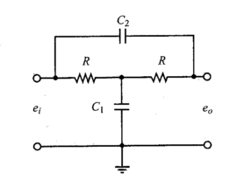  Fig.7
Q.10 | Obtain the transfer function of the signal flow graph using Mason’s gain formula.  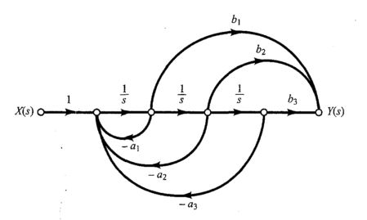  Fig.8

